# INVESTMENT STUDY

# <Abstract>

By using CRISP – DM framework I have tried to find out the best Sector wise and country wise Investment

options and suggested the same to CEO.

I have followed several steps such as Understanding the Business problems by creating sub problems, Preparation of clean data and Exploratory Data Analysis on the top to identify the optimum results. I have added the relevant results along with Problem Solving framework in the subsequent slides. Base on my initial finding I recommended to invest in Venture Type of funding in three countries like USA , GBR and IND.

I have attached a details of Companies related to Each country in the subsequent slides.

# <Problem solving methodology>

CRISP –DM Framework

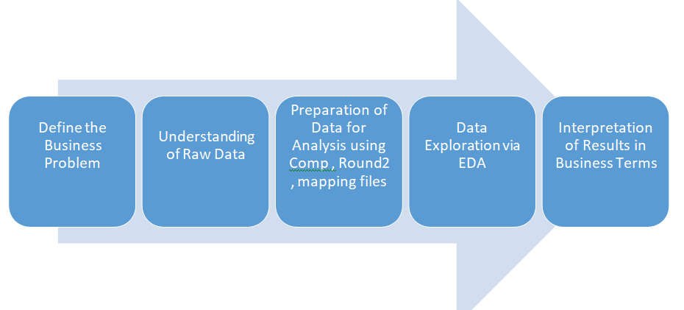

# <Define the Business Problem>

Spark Funds wants to make investments in a few companies. The client wants to understand the global trends in investments so that she can take the investment decisions effectively.

# <Preparation of Raw Data>

* Preparation of Raw Data using three different files Companies , Round and Mapping.
* Selected the Required Clean data by removing duplicate rows + Missing Value Treatment + Filtered data based on Investment Range ( 5- 15 million).
* Corrected the Mapping file information by changing the unwanted alphanumeric /numeric characters.

# <EDA> Exploratory Data Analysis

**Funding Type wise Investment Raised Amount**

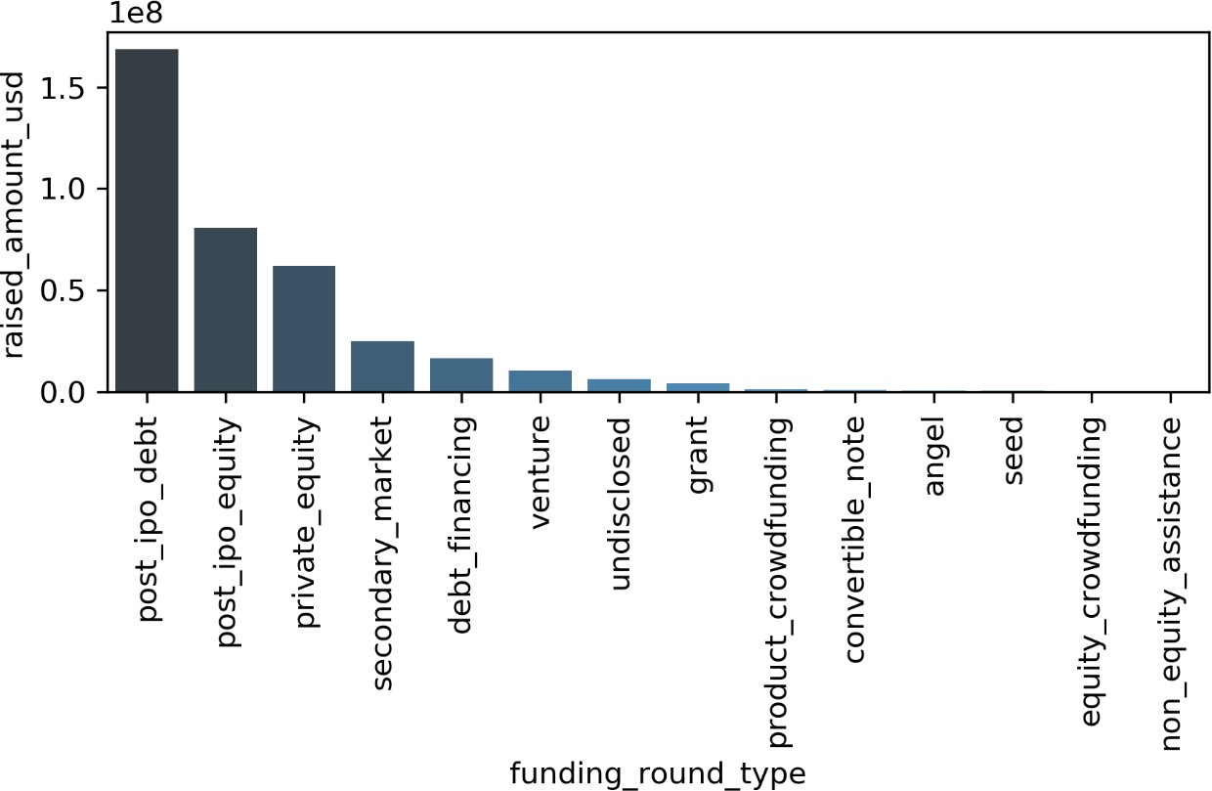

# <Results>

**Country wise Investment Raised Amount (Included the BLANKS i.e. for which No Country code is given)**

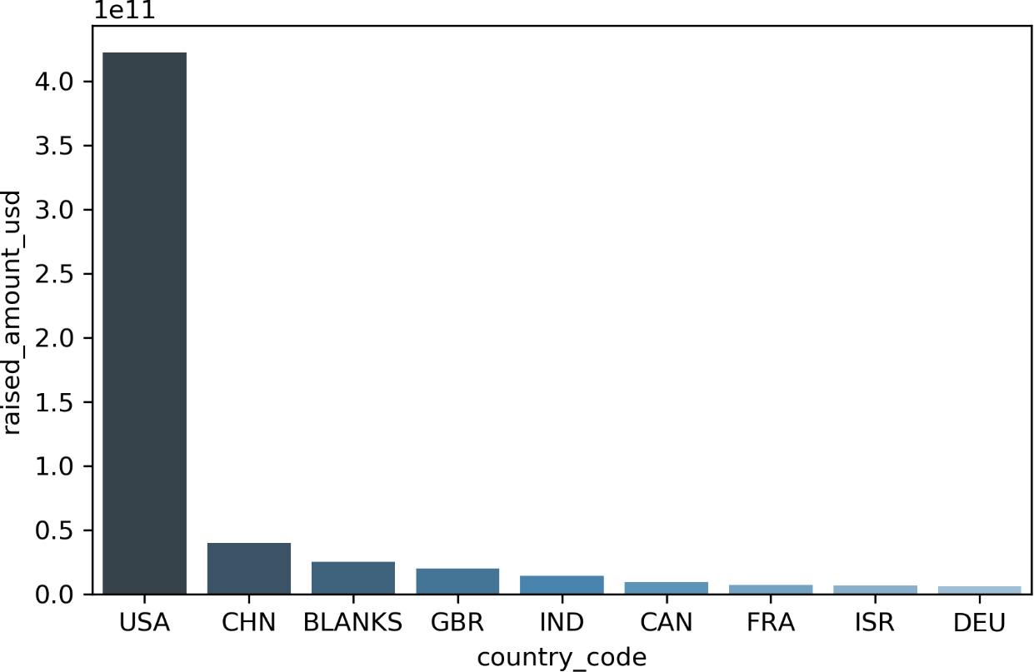

# <USA>

**Main sector wise Investment Count + Top 3 companies under Top 2 sectors**

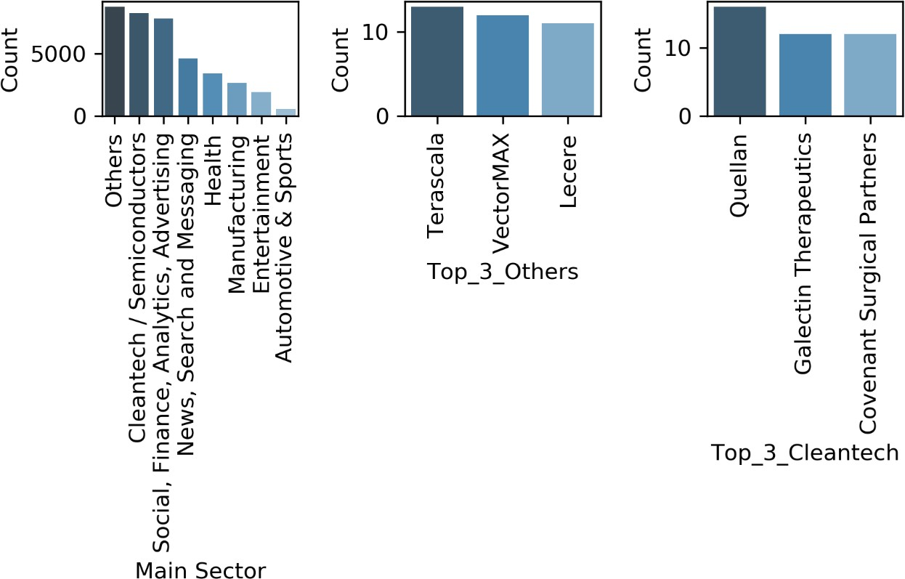

# <GBR>

**Main sector wise Investment Count + Top 3 companies under Top 2 sectors**

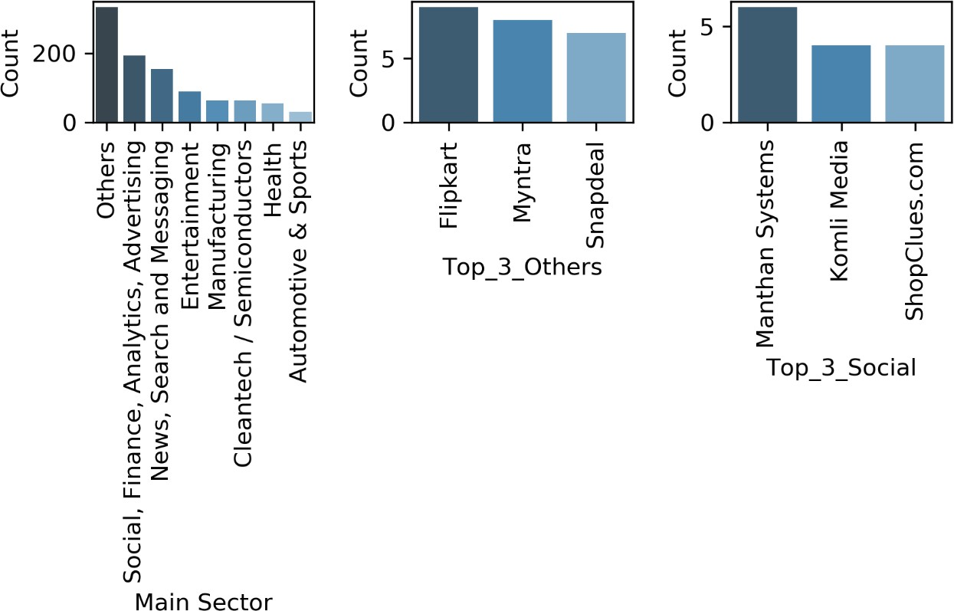

# <IND>

**Main sector wise Investment Count + Top 3 companies under Top 2 sectors**

# <Conclusions>

Base on my initial finding I recommended to invest in Venture Type of funding in three countries like USA ,

GBR and IND. Sector wise + Companies wise details has been attached in the previous slides.